**Assignment 1 – PS07 – Dam Construction –**

**Problem Statement**

A river flows through multiple states and junctions, you are tasked to identify potential locations

for dam construction to prevent flooding.

The river system is represented as a **directed graph**:

● **Nodes (Vertices):** Junctions or locations along the river.

● **Edges (Arrows):** River flows, directed downstream.

● **Weights (Values):** Volume of water flowing along the edge.

Dams should ideally be constructed at **junctions** where:

1. Multiple branches split (to control downstream flow).

2. High flow capacities exist for significant water storage potential.

A node qualifies for dam construction if the outgoing water flow at that node exceeds or equals

to **‘X’** (considered as **250 units** for the below example) **units**. The nodes represent river

junctions or states, and the edges represent river flows between them. The graph is as follows:

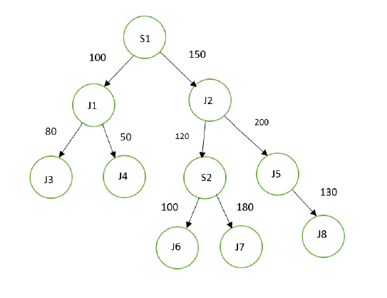

**Requirements:**

1. Formulate an efficient algorithm to perform the above task using BFS.

2. Provide a description about the design used and the rationale behind the design choice.

3. Analyze the time complexity of the algorithm.

4. Implement the above problem statement using Python 3.7 and above.

**Sample Input**

Input should be taken in through a file called “inputPS07.txt” which has the fixed format

mentioned below using the “/” as a field separator:

<node 1> / <node 2> / <distance in km>

Ex:

S1/J1/100

S1/J2/150

J1/J3/80

….

***Note that the input/output data shown here is only for understanding and testing,***

***the actual file used for evaluation will be different.***

**Sample Output**

**BFS Traversal Output:** S1 →J1 → J2 → J3 → J4 → S2 → J5 → J6 → J7 → J8

**Dam constructed at Locations:**

1. **Node S1:**

o Splits into Node J1 and Node J2.

o Total outgoing flow = 100 + 150 = **250**.

o Suitable for moderate dam construction.

2. **Node J2:**

o Splits into Node S2 and Node J5.

o Total outgoing flow = 120 + 200 = **320**.

o Ideal location for a major dam due to high flow.

3. **Node S2:**

o Splits into Node J6 and Node J7.

o Total outgoing flow = 100 + 180 = **280**.

o Suitable for moderate dam construction.